Practical User's Manual

Electric Fireplace

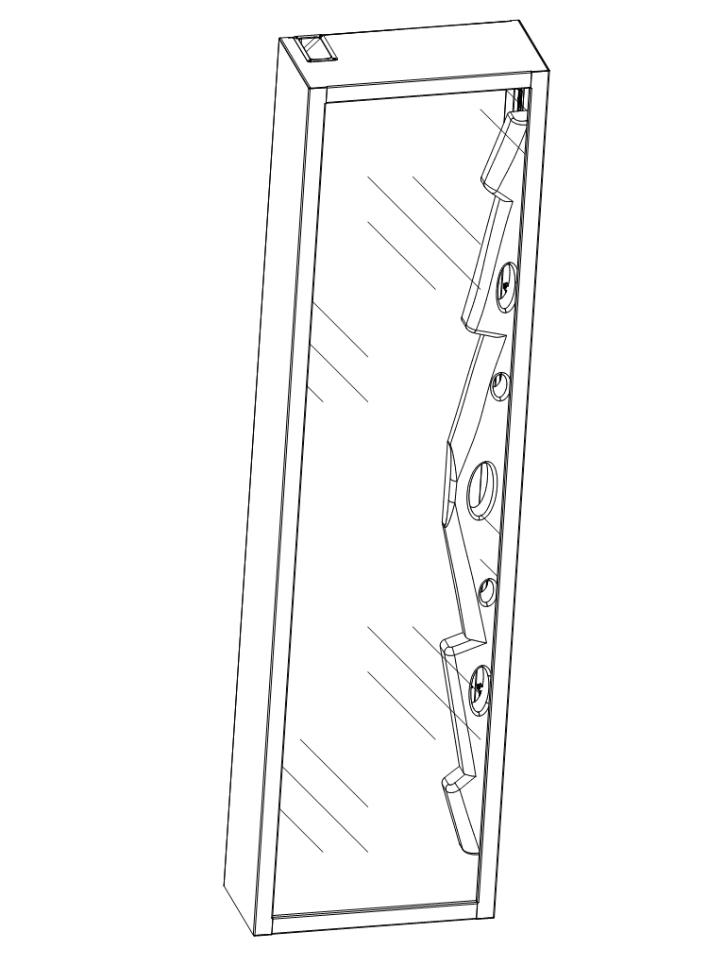

Read this owner's manual very carefully before using it

Please retain for future reference

INSTRUCTIONS FOR USE
IMPORTANT: It is important to read these instructions carefully before using the appliance for the first time. Keep the instructions safe so that you can refer to them later if necessary.

IMPORTANT INSTRUCTIONS:
When using electrical appliances basic precautions should always be followed to reduce the risk of fire, electric shock and injury to persons, including the following:
1) Read all instructions before using this heater.
2) This heater is hot when in use. To avoid burning, do not touch hot surface. If provided, use handles when moving this heater. Keep combustible materials, such as furniture, pillows, bedding, papers, clothes, and curtains at least 1 m from the front of the heater and keep them away from the sides and rear. In order to avoid overheating, do not cover the heater.
3) Extreme caution is necessary when any heater is used near children or the infirm and whenever the heater is left operating and unattended.
4) Always unplug heater when not in use.
5) Do not operate any heater with a damaged cord or plug or after the heater malfunctions, has been dropped or damaged in any manner, return heater to authorised service facility for examination, electrical or mechanical adjustment, or repair.
6) Do not use outdoors.
7) This heater is not intended for use in bathrooms, laundry areas and similar indoor locations. Never locate heater where it may fall into a bathtub or other water container.
8) Do not run cord under carpeting. Do not cover cord with throw rugs, runners, or similar coverings. Arrange cord away from traffic area and where it will not be tipped over.
9) To disconnect heater, turn controls to off, then remove plug from outlet.
10) Do not inset or allow foreign objects to enter any ventilation or exhaust opening as this may cause an electric shock or fire, or damage the heater.
11) To prevent a possible fire, do not block air intakes or exhaust in any manner. Do not use on soft surfaces, like a bed, where openings many become blocked.
12) A heater has hot and arcing or sparking parts inside. Do not use it in areas where gasoline, or flammable liquids are used or stored.
13) Use this heater only as describes in this manual. Any other use not recommended by the manufacturer may cause fire, electric shock, or injury to persons.
14) DANGER-HIGH Temperatures may be generated under certain abnormal conditions. Do not partially or fully cover or obstruct the front of this heater.
15) Replacement of the lamps should be done only while the heater is disconnected from the supply circuit.
16）This appliance is not intended for use by persons (including children) with reduced physical, sensory or capabilities, or lack of experience and knowledge, unless they have been given supervision or instruction concerning use of the appliance by a person responsible for their safety.Children should be supervised to ensure that they do not play with the appliance.
17) CAUTION: In order to avoid a hazard due to inadvertent resetting of the thermal cut-out, this appliance must not be supplied through an external switching device, such as a timer, or connected to a circuit that is regularly switched on and off by the utility.

Glass

Special characteristics of this heater
1、The smouldering glow of the flames can hardly be distinguished from that of a real fireplace.
2、Operated with Remote only

Unpacking and installing the appliance
Open the packaging carefully and remove the appliance. Keep the original packaging for future transport.
Keep the front of the appliance through which the heat is radiated at least one meter away from furniture, curtains and other flammable objects at all times.
Ensure there is a grounded socket nearby(back of the appliance).
Never use an extension lead. The mains cable must remain at the back of the appliance and must not be in contact with any hot elements.

Safety instructions:
Only use the appliance in accordance with the instructions in this manual! It cannot be used for any other purpose.
Never operate the appliance when the appliance itself or the main cable show any signs of damage.
In order to avoid overheating, do not cover the heater.
Be responsible when handling the packing material. Warning: plastic wrapping may be lethal to children.
Do not place the appliance next to a socket.
Never operate the heater on a program switch, timer switch or any other appliance for automatic operation.
The heater is only suitable for indoor use.
Never use the heater in the bathroom, shower or near a swimming pool.
The heater must not be located immediately below a socket-outlet
If the supply cord is damaged, it must be replaced by the manufacturer or its service agent or a similarly qualified person in order to avoid a hazard.
Never leave small children unattended near the appliance.
In case of malfunction, disconnect the plug immediately.
When not in use for a considerable amount of time, unplug the appliance.
Components should only be serviced by an approved electro technician.

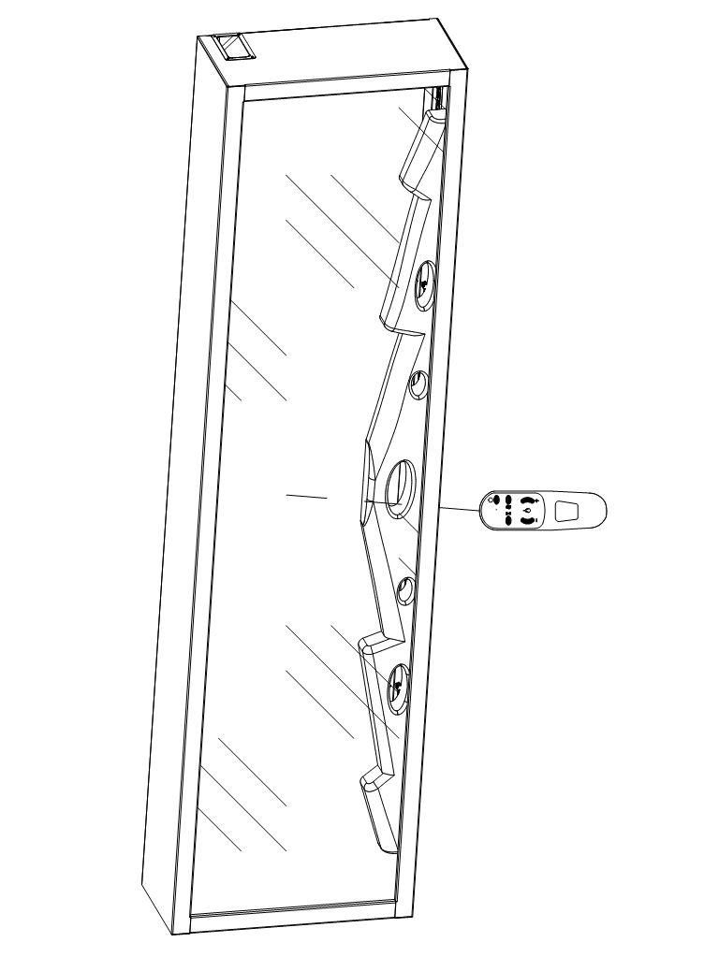

DIAGRAM OF THE REMOTE CONTROLLER

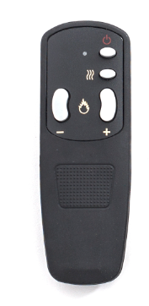
Remote Control Operation
BUTTON | FUNCTION | ACTION & INDICATION
  POWER | ON: Enables control panel functions and remote control. Turns on flame effect.  OFF: Disables control panel functions and remote control. Turns off flame effect. | 1. Press once. Indicator light turns on. Power turns on. All functions enabled.  2. Press again. Flame effect turns off. Unit goes to standby. All functions turn off.
HEATER | No function
 FLAME - | FLAME “-”: Makes flame effect dimmer.  NOTE: Flame effect stays on until power button is turned off. Flame effect must be on for heater to turn on. | 1. Press once. Flame effect gets dimmer.  2. Press again until desired setting is reached. Flame effect continues to get dimmer each time button is pressed.
FLAME + | FLAME “+”: Makes flame effect brighter.  NOTE: Flame effect stays on until power button is turned off. Flame effect must be on for heater to turn on. | 1. Press once. Flame effect gets brighter.  2. Press again until desired setting is reached. Flame effect continues to get brighter each time button is pressed.
Remote Control Device It is operated by AAA(#7)batteries. Point it directly towards the fireplace and it functions within a distance of approx 3.5m. The functions are similar to that of the Control Panel.

Cleaning the exterior of the appliance
Before cleaning the appliance, disconnect it from the socket and leave to cool.
You can clean the exterior of the heater with a soft, damp cloth.
Do not use cleaning or polishing products.

Manufacturers guarantee
There is guarantee of one year. During this period, faulty components will be repaired or replaced free of charge, if the fault is due to a manufacturing defect.
In this case, consult the retailer where you have purchased the appliance.
(Below some more instructions for the approved electro technician who carries out maintenance or repairs to your heater):

CAUTION: sharp edges!
You can now replace faulty bulbs by identical ones with the same wattage.
For assembly, proceed in reverse order.
1. After installation, the power plug should be accessible.
2. If the power cord is damaged. It must be replaced by the manufacturer or its service agent or a similarly qualified person in order to avoid a hazard.
3. The heater must not be located immediately below a socket.
4. The appliance is not intended for use by young children or infirm persons. Young children should be supervised to ensure that they do not play with the appliance.
5. Do not use this heater in the immediate surroundings of a bath, a shower or a swimming pool.
6. In order to avoid overheating, do not cover the heater.

Technical data:
Rated Voltage: 220V
Rated Frequency: 50Hz
Rated Power: 20W

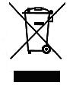

Meaning of crossed –out wheeled dustbin:
Do not dispose of electrical appliances as unsorted municipal waste, use separate collection facilities. Contact you local government for information regarding the collection systems available. If electrical appliances are disposed of in landfills or dumps, hazardous substances can leak into the groundwater and get into the food chain, damaging your health and well-being.
When replacing old appliances with new ones, the retailer is legally obligated to take back your old appliance for disposals at least free of charge.

